

D.Y. PATIL COLLEGE OF ENGINEERING & TECHNOLOGY, KASABA BAWADA, KOLHAPUR

A

Project Synopsis On

“Smart Street Lights”

Presented by:

Sr. No. Roll No. Name

1. 42 Aditya Sanjay Chavan
2. 47 Anish Ajit Jarag
3. 49 Tejas Jaywant Salokhe
4. 50 Mandar Mahesh Powar

Under the guidance of Prof. S. Kore

DEPARTMENT OF COMPUTER SCIENCE AND ENGINEERING (2022-2023)

Class: SY Division: B Batch: S2

INDEX

|  |  |  |
| --- | --- | --- |
| Sr. No. | Title | Page No |
| 1 | Introduction | 3 |
| 2 | Problem statement | 4 |
| 3 | Objectives | 5 |
| 4 | Proposed System Architecture | 6 |
| 5 | Modules | 7 |
| 6 | System Requirement | 9 |
| 7 | Conclusion | 11 |
| 8 | Reference | 12 |

**1. Introduction**

The rapid urbanization of cities has increased the demand for efficient and sustainable lighting solutions for public spaces, such as streets and roads. Traditional street lighting systems are often inefficient, as they are designed to operate based on fixed schedules, resulting in unnecessary energy consumption and increased maintenance costs. To address these challenges, the proposed project aims to develop a smart street lighting.

The aim of the Smart Street Lights project is to design a system that automatically turns on and off street lamps based on real-time environmental. This system is intended to be more energy and cost-efficient than conventional street lighting because the time of sunrise and sunset changes throughout the year, particularly in seasons like summer and winter. Conventional street lighting frequently wastes energy by turning lights on too early or off too late. Even during the day, street lights are frequently on.

**2. Problem Statement**

Street lamps of poor quality are not stabilized in lighting performance, which will cause a lot of problems for later maintenance and replacement work. It is very common to see the street light alight all day, which is a great waste of energy. The power consumption is relatively high day by day.

Smart Street lighting system is designed to automatically switch ON the Street Light alongside the roads (or path) on the onset of dark weather or at dusk & switch them off automatically after sunrise or during the light hours.

In the smart street light system is has lowered repair and maintenance costs with the monitoring software then regular street light. The smart street light system is eco-friendly & hence helps in reducing the carbon footprint.

**3. Objectives**

**Energy and Light Pollution:** The primary objective of the smart street lighting system is to conserve energy and reduce light pollution. The system will be designed to switch street lights on and off automatically based on the amount of ambient light in the area. This will prevent unnecessary energy consumption and lessen the amount of light pollution, thereby promoting energy efficiency and sustainability.

**Wireless Communication:** The proposed system will utilize a wireless communication system that will enable the lights to be monitored and managed remotely. This will provide greater flexibility and control over the lighting system, allowing authorities to adjust the lighting as necessary and reduce energy consumption during periods of low activity.

**Scalability and Integration:** Another important objective of the system is to be highly scalable and adaptable, allowing for easy integration with the infrastructure of currently installed street lights. The system will be designed to be modular, which will enable easy replacement and upgrade of individual components. This will allow the system to be easily expanded or contracted depending on the requirements of the specific location.

**Reliability and Durability:** To ensure the system's success, it is essential to design it to be highly dependable, strong, and able to withstand harsh weather conditions and vandalism. The system will be designed with robust materials and built to withstand extreme weather conditions such as strong winds, rain, and snow. Furthermore, the system will be designed with anti-vandalism measures in place to prevent damage to the system.

**Cost Reduction:** Finally, the system will aim to lower the cost of maintaining public illumination. The proposed system will reduce the need for human intervention in the maintenance of the street lights, as the system will be able to detect and report faults automatically. This will reduce the need for regular maintenance and repair, leading to cost savings in the long run.

**4. Proposed System Architecture**

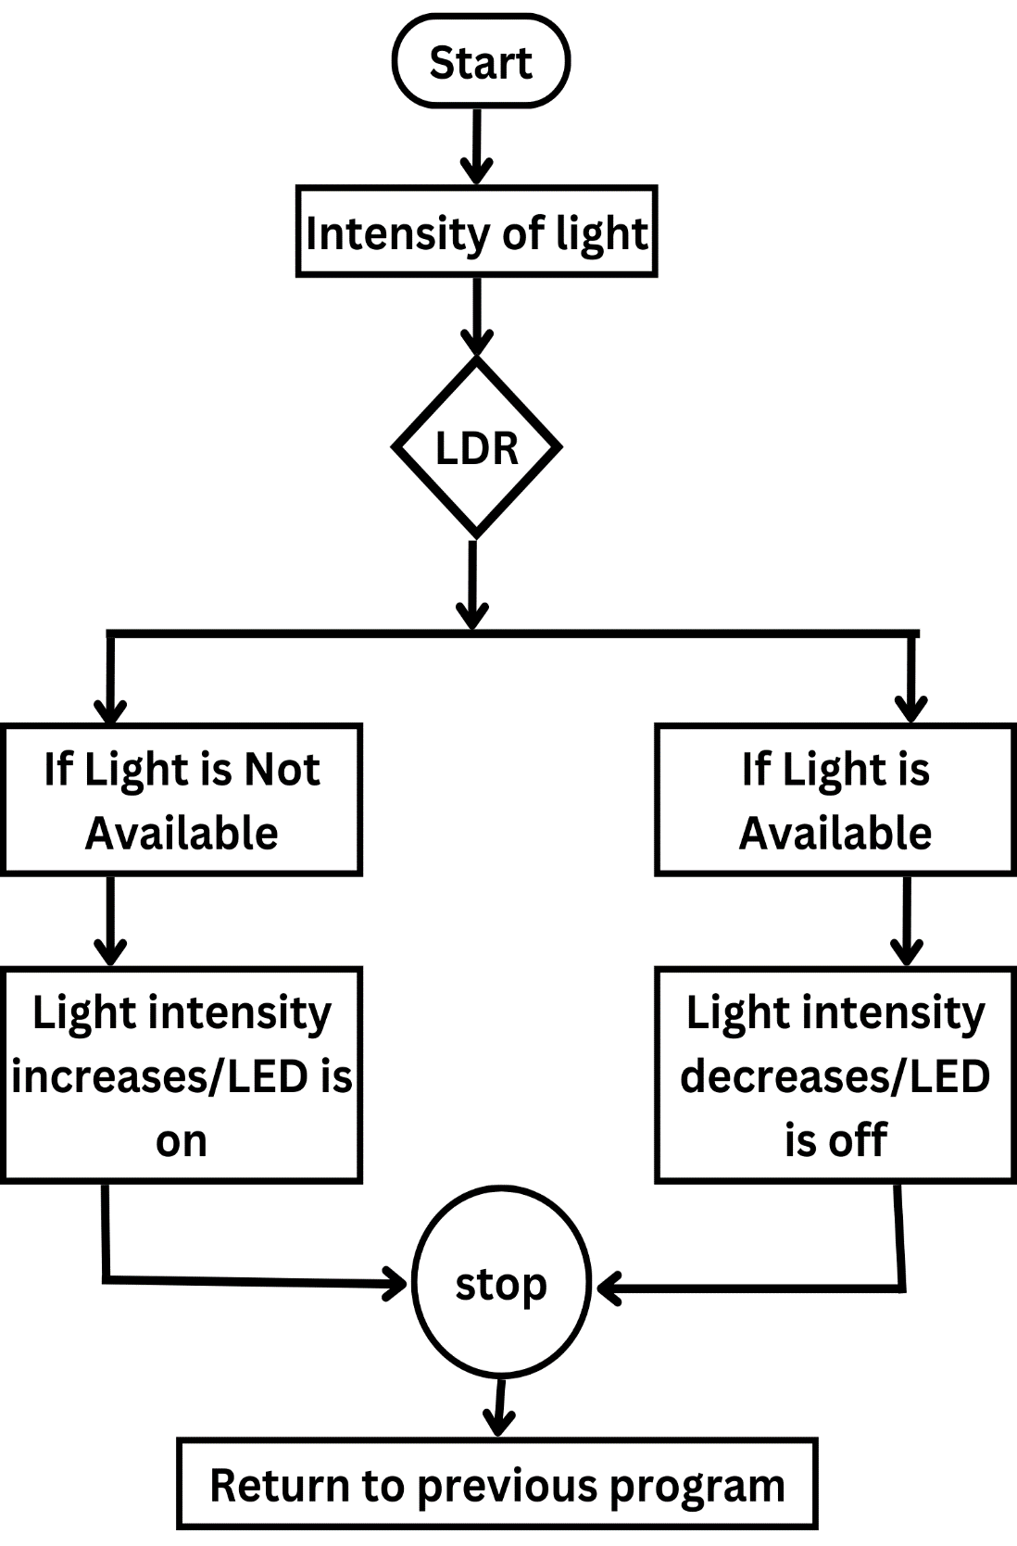

**5. Modules**

1. **Arduino Uno Board:**

Arduino Uno is a microcontroller board based on the ATmega328P microcontroller. It has 14 digital input/output pins, 6 analog inputs, a 16 MHz quartz crystal, a USB connection, a power jack, and an ICSP header. The board is designed to be easy to use and is suitable for beginners as well as advanced users. Arduino Uno can be programmed using the Arduino software, which is an open-source integrated development environment (IDE) that includes a code editor, a compiler, and a debugger. The board is commonly used in various projects including robotics, home automation, and IoT applications. It is a popular due to its low cost, simplicity, and versatility.

1. **Light Sensor Module:**

A Light Sensor Module consists of an electronic component that is used to detect the ambient light level in its surroundings. It consists of a photodiode or a photoresistor, which is a type of resistor that changes its resistance depending on the amount of light that falls on it. The module provides an analog output that can be read by a microcontroller such as Arduino Uno to adjust the brightness of the streetlights based on the ambient light levels. The Light Sensor Module can be used in various applications such as automatic lighting systems, smart homes, and security systems. It is a low-cost and simple solution for detecting light levels and can be easily integrated with other electronic components.

1. **LED Light Module:**

An LED Light Module is an electronic component that consists of Light Emitting Diodes (LEDs) that are used to provide illumination in various applications. In the Smart Street Lights project using Arduino Uno, LED Light Modules are used to provide the illumination for the streetlights. The brightness of the LED light can be controlled using pulse width modulation (PWM) signals generated by the Arduino Uno board. The LED Light Module is a low-power and energy-efficient solution for lighting applications, and it has a long lifespan compared to traditional lighting sources. It can be easily integrated with other electronic components and can

be used in various applications such as automotive lighting, street lighting,

and backlighting.

1. **Communication Module:**

A Communication Module is an electronic component that enables communication between different devices or systems. In the Smart Street Lights project using Arduino Uno, a communication module is used to enable remote monitoring and control of the streetlights through the internet. This allows for real-time adjustments of the lighting levels, providing greater flexibility and control. The communication module can be based on various technologies such as Wi-Fi, Bluetooth, or GSM, and can be integrated with the Arduino Uno board to enable wireless communication. The communication module is a key component in IoT applications and can be used in various applications such as home automation, industrial control, and smart cities. It is a versatile solution for enabling communication between different devices and systems.

1. **Power Supply Module:**

A Power Supply Module is an electronic component that provides the necessary voltage and current to power electronic devices. In the Smart Street Lights project using Arduino Uno, a power supply module is used to provide the required voltage and current to power the Arduino Uno board and the LED Light Modules. The power supply module can be designed to accept various input voltages and convert them to the required output voltage using various technologies such as linear or switch-mode voltage regulators. The power supply module can also provide protection features such as overvoltage protection, overcurrent protection, and short-circuit protection to ensure the safety and reliability of the electronic devices. The power supply module is a critical component in electronic systems, and it can be used in various applications such as industrial control, automotive, and aerospace. It is a versatile solution for providing power to electronic devices.

**6. System Requirements**

**Hardware Requirements:**

• Power supply

• LDR sensor

• NODEMCUESP8266

• Relay

• Bulb

**Power Supply Power** supply is a reference to a source of electrical power. A device or system that supplies electrical or other types of energy to an output load or group of loads is called a power supply unit or PSU. The term is most commonly applied to electrical energy supplies, less often to mechanical ones, and rarely to others. This power supply section is required to convert AC signal to DC signal and also to reduce the amplitude of the signal. The available voltage signal from the main is 230V/50Hz which is an AC voltage, but the required is DC voltage with the amplitude of +5V and +12V for varies applications.

**NODEMCUESP8266** The NodeMCU (Node MicroController Unit) is an opensource software and hardware development environment that is built around a very inexpensive System-on-a-Chip (SoC) called the ESP8266. And, you have to program it in low-level machine instructions that can be interpreted by the chip hardware. The ESP-8266 may be a low-cost Wi-Fi microchip with full TCP/IP Transfer control protocol/ Internet protocol). It makes the web connectivity possible for the IOT panel. ESP8266 offers a whole and self-contained W-Fi. • 2.4 GHz Wi-Fi (802.11 b/g/n, supporting WPA/WPA2). • General-purpose input/output (16 GPIO). • Inter-Integrated Circuit (I²C) serial communication protocol. • Analog-to-digital conversion (10-bit ADC). • Serial Peripheral Interface (SPI) serial communication protocol. Figure 2: WiFi module ESP8266

**LDR sensor Photo resistors**, also known as light dependent resistors (LDR), are light sensitive devices most often used to indicate the presence or absence of light, or to measure the light intensity. The sensor that can be used to detect light is an LDR. Since the LDR gives out an analog voltage, it is connected to the analog input pin on the Arduino. The Arduino, with its built-in ADC (analog-to-digital converter), then converts the analog voltage (from 0-5V) into a digital value in the range of (0-1023). Figure 3: Light Dependent Resistor (LDR) sensor

**Relay Board Relay boards** are computer boards with an array of relays and switches. They have input and output terminals and are designed to control the voltage supply. Relay boards provide independently programmable, real-time control for each of several onboard relay channels. A relay is an electrically operated switch that can be turned ON or OFF, letting the current go through or not, and can be controlled with low voltages, like the 5V provided by the NodeMcu pins. Controlling a relay module with the NodeMcu is as simple as controlling any other output. A relay is usually an electromechanical device that is actuated by an electrical current. The current flowing in one circuit causes the opening or closing of another circuit. Relays are like remote control switches and are used in many applications because of their relative simplicity, long life, and proven high reliability. Although relays are generally associated with electrical circuitry, there are many other types, such as pneumatic and hydraulic. Input may be electrical and output directly mechanical, or vice versa. Relays are mainly made up for two basic operations. One is low voltage application and the other is high voltage. For low voltage applications, more preference will be given to reduce the noise of the whole circuit. For high voltage applications, they are mainly designed to reduce a phenomenon called arcing.

**LEDs** use much less energy than incandescent bulbs because diode light is much more efficient, power-wise, than filament light. LED bulbs use more than 75% less energy than incandescent lighting. Another advantage of LEDs is the “hassle factor.” LEDs last a lot longer than a regular bulb**.**

**Software Requirements:**

**Arduino IDE** The Arduino Software (IDE) is an open-source software and it makes easy to the code and upload it to the board. I t runs on the different plant from Windows, MAC OS, Linux. The environment is written in Java and before running the IDE Java software to be installed on the machine this software can be used with any Arduino board.

**Thingspeak ESP8266** Thingspeak is an analytic IoT platform service that allows you to aggregate, visualize and analyze live data streams in the cloud. ThingSpeak is an open wellspring of web of things (IoT) utility and API to purchase and recover records from issues abuse the hypertext move convention and MQTT convention over internet or through a near to space organize. ThingSpeak licenses the presentation of detecting component work programs, area following bundles, and an informal community of things with standing updates.

**7. Conclusion**

In conclusion, this project outlines the design and development of a smart street lighting system that is energy-efficient and cost-effective. By utilizing Arduino Uno, the system can automatically dim the lights based on ambient light, detect motion, and provide remote monitoring and control. The future scope of the project includes expanding the system to cover larger areas, integrating other smart city technologies, and using renewable energy sources. Overall, this project aims to improve the efficiency and sustainability of street lighting systems, ultimately contributing to the development of smarter and more sustainable cities.

**8. Reference**

https://www.researchgate.net/publication/348096383_Smart_Street_Lighting_System

https://www.arduino.cc/en/about

https://www.techtarget.com/iotagenda/definition/smart-streetlight#:~:text=A%20smart%20streetlight%20is%20a,introduce%20real%2Dtime%20monitoring%20functionalities

https://www.oracle.com/in/internet-of-things/what-is-iot/

# Group-

|  |  |  |  |
| --- | --- | --- | --- |
| **Sr. No** | **Roll No.** | **Name** | **Sign** |
| 1 | 42 | Mr. Aditya Sanjay Chavan |  |
| 2 | 47 | Mr. Anish Ajit Jarag |  |
| 3 | 49 | Mr. Tejas Jaywant Salokhe |  |
| 4 | 50 | Mr. Mandar Mahesh Powar |  |

Date:

Place: Kolhapur

**Prof. S.Kore Prof. A.P.Bhudargade Prof. R. J. Dhanal**

(Project Guide) (Project Coordinator) (HOD)